AND THE FED MAKES MONEY

MONEY MAKES THE WORLD GO ‘ROUND

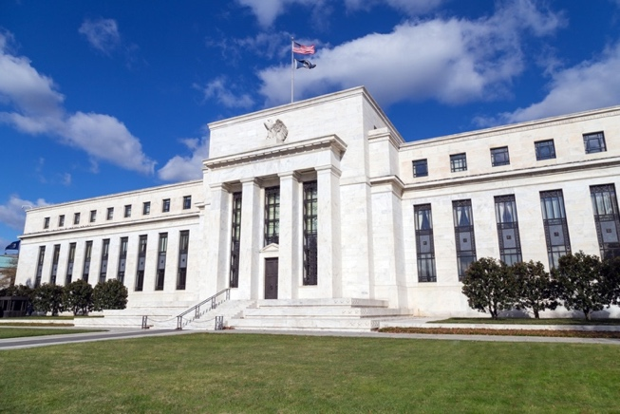
Gripped by fear over possible “contagion” from the subprime mortgage fallout, the stock market tumbled in early August 2007, giving up all of its gains for the year. Fearing a possible liquidity crisis, the Fed injected $38 billion in temporary reserves on August 10—the largest such move since the September 11 crisis—and then unexpectedly cut the discount rate 50 basis points one week later. The markets cheered in response, while malcontents grumbled that the Fed was merely bailing out its hedge fund cronies and risked letting the inflation genie out of the bottle.
The Federal Reserve Bank in Washington, D.C.
Clearly the Federal Reserve is an incredibly powerful institution. As the title of this paper suggests, the Fed (and to a lesser extent, other large central banks) literally has the power to nurture or wreck the global economy. Yet despite its tremendous importance, the Fed remains a mysterious entity for most people, including policymakers. In this paper I hope to pierce the fog by applying basic economic principles to this intimidating topic.
How the Fed Creates Money
Our topic would be much simpler if there weren’t fractional reserve banking, or better yet if everyone conducted their transactions in cold hard cash. But this isn’t our world. To understand the process by which the Fed creates money, we first need to understand the institutional setup.
Banks in the United States are subject to reserve requirements, meaning that they must be able to “back up” some portion of the outstanding checkbook balances of all of their customer accounts with reserves, which can consist of either cash in the vault or deposits that the bank has with the Fed itself. For example, if a particular bank had 1,000 checking accounts opened by its customers, and the accounts had an average balance of $500, then the bank’s total deposits would be $500,000. If the Fed sets the reserve requirement at 10%, then this particular bank must maintain reserves of at least $50,000; perhaps the bank would have $40,000 in actual cash in its vaults, and a $10,000 balance on deposit with the Fed itself.
Because the reserve requirement is less than 100%, we have what is called a fractional reserve system. This is why bank runs are theoretically possible. In our hypothetical example above, if for some reason the bank’s customers doubted the safety of their deposits, they couldn’t all withdraw their money; the customers in the aggregate believe that they have $500,000 on deposit with the bank, but even counting its reserves with the Fed, the bank only has $50,000 it can hand out. It was precisely to quell this type of self-fulfilling prophecy that the government instituted FDIC insurance of bank deposits (now up to $100,000) during the Great Depression.
Now we’re in a position to understand how the Fed “creates money.” The layperson probably imagines a printing press cranking out crisp new $100 bills, but that’s not really how it works. When the Fed wants to increase the money supply, in practice what it really wants to do is expand the total amount of demand deposits (think of checking account balances) held by the public as a whole. Since the sum of demand deposits must be backed up by reserves, the Fed increases the money supply by either (a) lowering the reserve requirement ratio or (b) increasing the reserves of the banking system.
The first option is easy enough to understand. If the Fed lowers the percentage of deposits that must be held as reserves, then a given amount of reserves can support a larger amount of money held by the public. In our hypothetical example from earlier, if the Fed lowered the reserve ratio from 10% to 5%, then our bank (with $40,000 in cash in the vault and $10,000 in reserves with the Fed) could approve additional loans to homebuyers and other customers to double its outstanding sum of checking account balances from $500,000 to $1 million. In other words, if the Fed cuts the reserve requirement in half, the customers of this bank can go from thinking they have (collectively) $500,000 that they can spend, to now thinking that they have twice as much—$1 million—that they can go use to buy goods and services.
In normal operations, the Fed doesn’t fiddle with the reserve ratio. Instead, it affects the money supply by altering the total amount of reserves in the banking system. There are two ways it does this. First, the Fed can change the discount rate, which is the interest rate that the Fed charges banks to borrow reserves from the Fed itself. Thus, if a particular bank gets into trouble and doesn’t have sufficient reserves to meet its legal requirements, as a last resort it can go to the Fed and borrow the shortfall. Naturally, cutting the discount rate tends to increase borrowing, while raising the discount rate tends to decrease it.
Yet there is a second way that the Fed can alter the total amount of reserves in the system, and we finally come to the most frequently used tool: the so-called “open market operation.” If the Fed wants to increase the money supply, it can enter the market and buy securities (such as government bonds) from member banks. It pays for these assets with reserves that are then added to the deposits that the member bank has with the Fed. In this way, the banks in question are eligible to make more loans to their own customers, because reserves on hand with the Fed count towards satisfying the reserve requirement, whereas government bonds and other securities cannot back up checkbook deposits. Of course, going the other way, if the Fed wants to restrict the money supply, it can sell assets to member banks, and the banks pay for these items by having their reserve balances with the Fed reduced. This then restricts the total demand deposits that these banks can maintain, because of the reserve ratio.
Before leaving this section, I should clarify one last point. In this entire operation, where does the “new money” come from? After all, if the government simply cranked out new rectangles of green paper bearing photos of Benjamin Franklin, it’s clear how the money supply is growing. But in our modern arrangement, the new money creeps in at the stage when the Fed buys assets and thus adds to the reserves of member banks. If, for example, the Fed buys $1 million in Treasury bonds from Bank XYZ, the Fed credits XYZ’s account with an additional $1 million in reserves. But there is no offsetting debit of $1 million from somewhere else; those new reserves were created “out of thin air,” as it were. And then on top of this, if the reserve ratio is 10%, then Bank XYZ can make up to $10 million in new loans to its own customers. Thus, the total quantity of money held by the public has grown by $10 million, but not because of an injection of 100,000 new greenbacks.
Money and Inflation
The late Milton Friedman’s motto that “inflation is always and everywhere a monetary phenomenon” contains much truth, and is precisely why it is so important to get monetary theory right. However, the connection between Fed policy and price inflation is not so clear cut as many commentators seem to think. In the context of unemployment and output, I gained some notoriety demonstrating that the Keynesians ignored the supply side at their peril. Perhaps ironically, in the context of monetary theory, I have taken great pains to show that the monetarists ignored the demand side—and consequently misinterpreted what happened in the early 1980s. In short order I’ll explain all of this, but first we need to review the basics of supply and demand. In order to make the analysis of money as painless as possible, we’ll first do the exercise with something easy, namely apples.
Supply and Demand: The Case of Apples
In the world of economics, everything is ruled by the law of supply and demand and price and quantity. The amount of goods and services people are willing to buy or hold depends on price, and the amount of goods and services people are willing to supply also depends upon price. At any moment in time there’s a unique price equilibrating the amount demanded with the amount supplied. Making the same point in another way, there’s a unique quantity equilibrating the price demanders are willing to pay and the price suppliers are willing to accept.
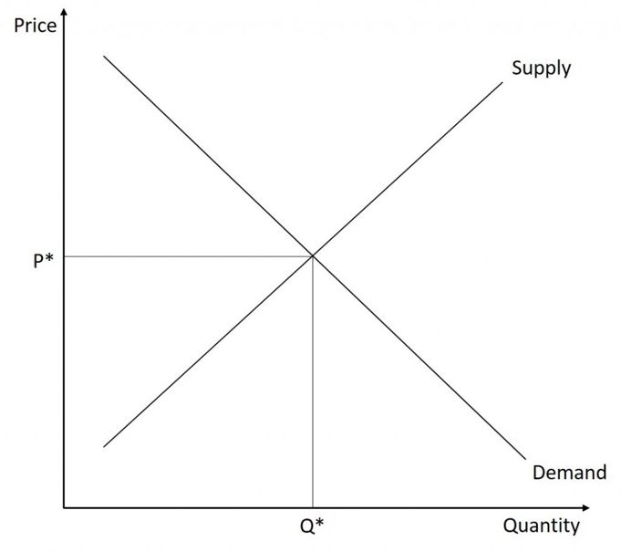
Supply and Demand Graph
That having been written, an outward shift in demand (a change in demand resulting from anything other than a change in price) will by itself lead to upward price pressure and upward quantity pressure. An inward shift in demand will do just the reverse.
Take apples, for example. If we discover apples have definite aphrodisiacal qualities—or, in the specific case of Californians, we discover that apples have hallucinogenic attributes previously unknown—then the demand for apples will increase, causing the price of apples to rise. This is an example of an outward shift in demand. The increase in the price of apples will then induce apple growers to pick their trees cleaner and to grow more apples. This is a movement along the supply curve. Thus, with an outward shift in demand there will be more apples at higher prices. Symmetrically, if apples were found to cause cancer or infertility, the demand for apples would fall (this is an inward shift in demand), leading to lower apple prices and fewer apples produced.
Disturbances can occur not only in the demand for products but also in their supplies. For shifts in supply there is an analogous set of responses. An outward shift in supply will lead to downward pressure on price and upward pressure on quantity, while an inward shift in supply will do just the opposite. It’s straightforward.
Continuing our apple example, if apple growers have an unexpected bumper crop of apples (an outward shift in supply), there will be an excess supply of apples, leading to lower apple prices which induce apple buyers to buy more apples. To wit: more apples and lower prices. With a crop failure (an inward shift in supply) there will be an excess demand for apples and fewer apples sold at the resulting higher prices. Shifts in the supply of apples lead to greater quantities at lower prices and lesser quantities at higher prices. Shifts in demand, however, lead to greater quantities at higher prices and lesser quantities at lower prices.
The important point in this discussion is that for shifts in supply, prices and quantities will move in opposite directions, while for shifts in demand, prices and quantities will move in the same direction. Therefore, just because we know what happens to quantity, we still have no idea what will happen to price. An increase in quantity can result from an outward shift in either supply or demand. In the former case prices will fall, while in the latter case prices will rise.
Supply and Demand: The Case of Money
Money, as magical as some people think it may be, is no different than any other commodity in the realm of economics. It has to obey the laws of supply and demand just like everything else. If the quantity of money increases because of an increase in supply, we find ourselves in the familiar terrain of monetarists where increases in quantities of money are associated with higher inflation, higher interest rates, higher gold prices, and a weaker currency. It is in this arena where the old saw “inflation is everywhere and at all times a monetary phenomenon” comes into play.
If, however, the quantity of money increases as a result of an increased demand for money, things start getting a little weird; inflation, interest rates, and the price of gold will fall, and currency will strengthen as quantities of money grow faster. Fast money growth can, conceptually at least, imply lower interest rates and inflation, just as well as higher inflation and interest rates. An analogous discussion could be had for reductions in the quantity of money resulting in higher inflation and interest rates. Now let’s see where all of this takes us.
Point one: The quantity of money (here we use the traditional definition of demand deposits plus currency in circulation, referred to as M1) is measured with ease. It’s done every day without fail. Measured just as easily is the monetary base (member banks’ reserves held at the Fed plus vault cash and currency in circulation). The Federal Reserve provides these data in incredible detail and on a timely basis.
Point two: For all practical purposes, the Fed completely controls the effective monetary base. It does this by open market operations, loans from the discount window, and changes in reserve requirements. Changes in the monetary base correspond to shifts in the supply of money. In contrast, changes in the quantity of money—i.e., changes in M1—constitute a change in the number of dollars being held, which could be due either to shifts in supply or demand. In order to gauge what happens to prices when the quantity of money changes, we need to understand what is happening both to supply and to demand.
Point three: We know, as discussed earlier, that if the increase in the demand for money exceeds the increase in the supply of money, then the price of money will rise. Here, the “price of money” is literally the number of goods and services that exchange for a single dollar; if a gumball costs 25 cents, then the market price of a U.S. dollar is four gumballs. That’s the price of money. Thus, when the demand for money increases more than the supply of money, the price of money rises, which is equivalent to saying dollar prices of goods and services will fall. The result is lower inflation.
Unfortunately, we do not have a direct measure for shifts in the demand for money. However, we do have high quality data on both the quantity of money (M1) and shifts in the supply of money (monetary base). The quantity of money and the monetary base taken together allow us to draw inferences about the demand for money relative to its supply, and in turn allow us to understand what will happen to the value of money, i.e., inflation. For example, if the demand for money should suddenly increase, there is no data series put out by the Fed that will tell us so. However, in this scenario we would observe M1 growth exceeding base growth (both statistics that are published by the Fed), and we would conclude that inflation was poised to fall.
Point four: Changes in the quantity of money are always a consequence of shifts in both supply and demand. The measure of the relative shifts in supply and demand, while not quite as intuitive as our other points, can be visualized. For example, if there’s an identical outward shift in supply and demand, then price won’t change and the quantity of money (M1) will increase by the outward shift in both supply and demand. If, on the other hand, demand shifts out yet supply doesn’t change, then the price of money will rise (i.e., inflation will fall) and the quantity of money will increase but not by as much as the outward shift in demand. Working through all sorts of examples will convince the reader of the fact that changes in the quantity of money are in fact a weighted average of the shifts in supply and demand. By using the growth rate of the monetary base relative to the growth rate of M1 (i.e., growth of money supply compared to the growth of the quantity of money) we can always tell whether money is easing or tightening. Armed with this knowledge, we should be able to make a reasonable judgment as to the future of inflation rates.
According to our theory, under all circumstances if the quantity of money grows faster than the supply of money, then we know the demand for money must have increased relative to the supply of money. This should lead to lower inflation. On the other hand, if the quantity of money grows less than the supply of money, then the demand for money has grown by less than the supply of money, thus resulting in higher inflation.
The important point here is that “the supply of money” and “the quantity of money” are not the same thing. The quantity of money— i.e., the actual equilibrium amount of currency and demand deposits in the economy at a given time—is not controlled directly by the government. The government certainly controls shifts in the supply of money via changes in the monetary base, but supply still must interact with everyone’s demand for money, just as the quantity of apples cannot be determined from knowledge of the supply curve alone.
This point is extremely important—without it you’ll never get monetary theory right. The behavior of private individuals interacts with official monetary policies in order to determine the equilibrium quantity of money (M1). This behavior can exaggerate or even offset government plans. For example, by withdrawing currency from the banking system and holding it as cash, individual one’s wallet is 100%. Banks, too, have discretion over the total quantity of money because they have the option of holding a higher fraction of reserves than the government-mandated minimum. Therefore, a given amount of reserves (directly set by the Fed) can support a larger or smaller aggregate amount of demand deposits depending on the reserve ratios desired by the banks.
We know that the demand for money increases relative to the supply of money whenever the quantity of money increases relative to the supply of money. The difference between growth of the monetary base and growth of the quantity of money is called excess base growth. Excess base growth is an incredibly powerful tool for analysis of financial markets, inflation, interest rates, spot commodity prices, and exchange rates.

When It Comes to Money, We Can’t Ignore the Demand Side: The Reagan Years
In the late 1970s, I explained shifts in the demand for money by asking people to imagine what would happen if everyone knew with perfect certainty that 20 years from now the value of one dollar—in terms of the goods and services it could buy—would be exactly the same as it is today. Interest rates, of course, would tum would soar in the foreign exchanges, as would stock prices. But, in addition, the quantity of dollars would increase because the demand for dollars would rise, eliciting greater supplies (a movement along the supply curve). Other factors being equal, wouldn’t you be more willing to hold a stable-valued currency than one that is depreciating rapidly? Of course you would. And this is exactly what happened in the early to mid-1980s in the U.S. under the able leadership of President Ronald Reagan and Federal Reserve Chairman Paul Volcker.
During the early 1980s, Milton Friedman and I had a number of lively discussions in our meetings with the president. In each, he warned that rapid growth in the quantity of money would soon lead to much higher inflation, while I said just the opposite. My view was that the rapid growth of money in the early 1980s was due to increases in the demand for money, while Friedman held that the quantity of money was one and the same as the supply of money.
Milton Friedman
The rest, as they say, is history. Inflation rates tumbled during the Reagan Revolution. Milton’s favorite statistic—the quantity of money per unit of real GDP—misled him, because he overlooked the fact that the pro-growth policies of the early 1980s made dollars much more attractive to hold. The value of a U.S. dollar went up even as the total quantity of dollars increased, just as a sudden rise in the demand for apples would lead to more apples and a higher value per apple.
The Fed Doesn’t Set Interest Rates—Yes, I’m Serious
As a concluding point, I want to emphasize that despite all the chatter on CNBC and in the press, the Federal Reserve does not directly set interest rates. The only interest rate the Fed controls is the discount rate (discussed previously), which is the rate the Fed charges on loans of reserves that it makes to banks. In terms of overall bank borrowing of reserves, the amount they get directly from the Fed through
In any event, we can ignore the (irrelevant) discount rate, because when the press talks about the Fed changing “interest rates,” what they have in mind is the federal funds target rate. The federal funds rate is the interest rate that banks charge each other for overnight loans of reserves. Do you see the irony? The Fed is neither a borrower nor a lender in this market, and yet it (allegedly) “targets” the price for such loans. In truth, the fed funds rate is set by the market forces of supply and demand, just as the Fed can’t “target” the price of oil or peanut butter. The easiest way to bust this particular myth is a chart like the following, which shows that the Fed’s much ballyhooed target clearly follows changes in the market-determined yield on the 91-day T-bill.
Now, the Federal Reserve indirectly influences interest rates—especially long-term ones—through its control of the monetary base, because as we saw above, the Fed’s policies affect the price level, i.e., the inflation rate. If lenders anticipate high rates of inflation, they will insist on higher nominal yields when they buy bonds. That’s why the tremendous disinflation of the early 1980s—associated with the wise leadership of Fed Chairman Volcker—led to such a sharp drop in interest rates. But my point is that the Fed doesn’t directly “set” interest rates the way the media would have us believe.

About the Author
Arthur B. Laffer is the founder and chairman of Laffer Associates, an economic research and consulting firm that provides global investment-research services to institutional asset managers, pension funds, financial institutions, and corporations. Since its inception in 1979, the firm’s research has focused on the interconnecting macroeconomic, political, and demographic changes affecting global financial markets.
Dr. Laffer has been widely acknowledged for his economic achievements. His economic acumen and influence in triggering a world-wide tax-cutting movement in the 1980s have earned him the distinction as the “Father of Supply-Side Economics.” He was also noted in TIME’s 1999 cover story on the “Century’s Greatest Minds” for inventing the Laffer Curve, which it deemed one of “a few of the advances that powered this extraordinary century.” His creation of the Laffer Curve was deemed a “memorable event” in financial history by the Institutional Investor in its July 1992 Silver Anniversary issue, “The Heroes, Villains, Triumphs, Failures and Other Memorable Events.”

We adjust the M1 and monetary base data, beginning in 1994, for the estimated effects of sweep accounts.

