GOVERNMENT & PROSPERITY

The Importance of Institutions
Many attribute the differences in economic performance across countries to factors such as natural resources, climate, education, culture, colonialism, or just dumb luck. Although each of these factors is certainly important, many economists have come to believe that institutions are far more significant in explaining economic development. After all, the U.S.S.R. had far more generous endowments of natural resources than Hong Kong, and yet the former had bread lines while the latter was an economic powerhouse. For a different example, consider the differences between East and West Germany, or North and South Korea—just about the closest thing to controlled experiments we have in macroeconomics.
It is clear that institutions matter. Specifically, those countries that have secure private property rights and the rule of law tend to have higher per capita incomes and faster economic growth. This is an empirical observation that cannot be denied. This correlation is no accident: there are very straightforward reasons why free, private markets work in practice, not just in theory.

Private property is the foundation upon which all of our other rights are based.
Private Property
In a system of private property, economic goods are owned by private individuals. Property rights give the owner the ability to use or transfer the item in any way he sees fit, without obtaining anyone else’s permission, so long as he doesn’t thereby violate someone else’s property rights. On the one hand the concept seems obvious, but on the other it was a fairly recent historical development largely confined to the Western European countries. Generally speaking, if private individuals in other regions had sole control of particular resources, the system (perhaps ironically) ensures greater attention to these resources than if “the community” owned everything collectively.
For example, when pasturelands were held “in common” in England centuries ago or in the American West
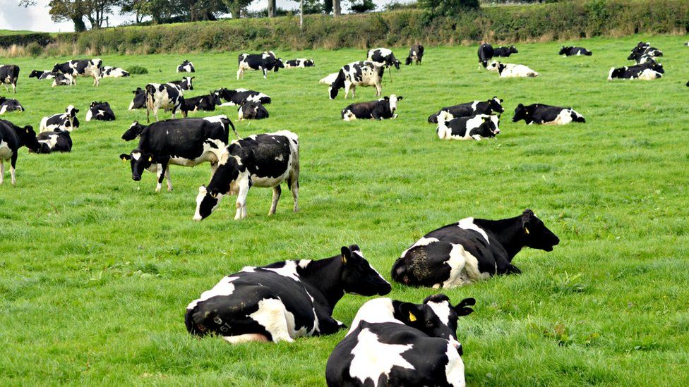
Solving the “Tragedy of the Commons” requires assigning property rights, not increased government regulations
before barbed wire, over- grazing was rampant. Each rancher or shepherd knew that it would be better to restrict his animals’ eating to allow the grass to replenish itself, but such restraint on the part of an individual would simply mean that someone else’s animals ate the grass. By the same token, even in modern times overfishing is a serious problem in “public” bodies of water. Each fisherman knows that it would be prudent to leave some fish for natural reproduction, yet he can’t control the actions of his peers and so everyone ends up catching more fish than is optimal.
Economists call this situation “the tragedy of the commons.” The solution for pastures was the enclosure movement, in which plots of land were parceled off and fenced in. When the previously public land was turned into private property, lo and behold the owner took much better care of the resource than the collective owners did before. And in modern times, privately owned and managed fisheries maintain healthy and growing populations of fish.
We can see examples of this principle in many areas. Endangered species are always “public” property, in that they are (ostensibly) protected by the government. As a result, no one ever hears of endangered species that are bought and sold on markets. Yet, for the most part, endangered species remained endangered under this protection scheme. On the other hand, even though humans voraciously consume pork, chicken, and beef, we don’t need government laws protecting pigs, chickens, or cattle from extinction. No, private property and the owners’ rational self-interest ensure that we always have a plentiful supply of these animals.
Recently, the assignment of private property rights as a solution to the tragedy of the commons has been ignored. Instead, such problems have been classified as externalities and seen as examples of market failure whereby the government must step in to remedy the problem. Pollution and fisheries are two of the most common externalities cited today.
The benefits of private property have been documented by Hernando de Soto, who has done painstaking research in his book The Mystery of Capital. He shows that entrepreneurship can only thrive in countries where government and local custom don’t needlessly hamper the use of private property in the formation of new businesses. If someone is considering opening a restaurant, he will be deterred by high taxes, hundreds of forms, corrupt inspectors who require bribes, and other obstacles that might needlessly put his property at risk. The same holds true for foreign investors. Who in his right mind would spend millions erecting a new factory in a distant land, if he feared that the domestic government might “nationalize” it at any moment?
The Function of Market Prices
In a system of private property, one of the outgrowths is a constantly fluctuating array of market prices. When private individuals have the right to transfer ownership of their property, they generate prices in the process of these exchanges. Prices are simply the ratios at which goods and services trade against each other. Under barter, these goods and services trade directly; Jones exchanges 10 apples for Smith’s five oranges, meaning the price of an orange is two apples. When one particular good is acceptable by virtually all parties in any exchange, then it is money and the price of every item is quoted in terms of the money commodity. But the principle is the same: if Jones exchanges $10 for five sandwiches, then the price of a sandwich is $2.
When people truly possess private property rights, they have the right to transfer their property at mutually agreeable prices. Economics teaches us that freely floating prices—i.e., true market prices—have an important job
Market prices simply reflect the ratios at which goods and services trade against each other.
to do, and that’s why it is important for politicians and moralists to let them do their job. Simply put, market prices allow firms to calculate the expected profit and loss from various ventures. They then shift activities out of losing areas and into profitable ones.
This behavior is exactly what society should want entrepreneurs to do. Profit is a reward for producing what people really want. Losses are the punishment for producing what people do not want. Individual consumers reward producers like Bill Gates handsomely while the same consumers have put many startup entrepreneurs into bankruptcy. In the process, business responds by jumping into that which is profitable and avoiding that which is not. This illustrates what Adam Smith called the “invisible hand,” whereby a free-market system harnesses the self-interested motivations of businesspeople and directs them to serve the interests of all.
Profit is the difference between revenues and costs. Businesses seek to maximize profit by producing what people want, giving the business as much revenue as possible, using as few resources as possible, and keeping costs low. What a wonderful outcome for society at large!
In a sense, profitable firms are taking resources of a certain value and transforming them into finished goods or services that are valued more highly; the firm’s profit is a direct measure of this “value added.” On the other hand, a firm that is losing money is channeling resources into areas where the consumers don’t really want them to go. After all, the reason the losing firm can’t cover its costs is that other firms are trying to bid away those same resources, in order to make products for their customers. The difference between a profitable versus an unprofitable firm is that the customers of the former are willing to pay enough and thereby generate sufficient revenues for its managers to attract the required resources, whereas the customers of the latter are not willing to pay enough for the finished product to allow its managers to compete for resources. The system of profit and loss thus ensures that society’s scarce resources are being used to best satisfy consumers’ desires. Not taking cost into account, everyone would like to drive gold-plated vehicles. But there are more urgent uses to which that gold could be put, and that’s why it would be far too expensive—i.e., unprofitable—for auto companies to produce gold-plated cars.
Market prices provide important signals to everyone in the economy, allowing for quick adjustments to new circumstances. If a new FDA report comes out, explaining that apples cure cancer, most people will greatly increase their apple purchases. This increased demand will push up apple prices sharply, at least in the short run. However, the higher prices will induce farmers to switch out of other crops and increase their planting of apple trees, as well as devote more attention to the existing crop of trees, to maximize the number of apples brought to market. As the supply of apples catches up with the heightened demand, the price will fall toward normal levels, but with a permanently higher quantity of apples produced each year. This outcome of the free market is exactly what the truly socially-minded central planner would want to have happen—namely, when people discover that apples have medicinal properties previously unknown, more farmland should be devoted to apples than before.
Market prices can also handle disruptions on the supply side, too. Suppose that a severe cold snap decimates the apple crop. The reduction in supply would lead to a sharp rise in apple prices, which would cause consumers to cut back on their purchases. Certain shoppers who had planned on baking apple pies might decide on cherry or blueberry instead. And the high prices in the area hit by the cold weather would draw in apples from other regions which were unaffected. Again, this is exactly the response that a “rational planner” would have designed, and it occurs spontaneously in the free market without oversight from any committee or group of experts.
One final example—this one more sophisticated than the apple scenarios—will serve to illustrate the social function of free market prices. In modern developed economies, there are not only spot prices for commodities, but also futures and forward prices. These are the prices of so-called derivatives, and allow people in the economy to adjust their plans to new information with even greater precision. For example, if experts generally expect the demand for oil to rise sharply in one year, the “obvious” reaction should be for oil companies to restrict their sale of oil in the present. And to an extent, this would happen even with simple spot prices. However, the element of uncertainty makes the adjustment somewhat halfhearted. The oil company might prefer to sell for $60 a barrel today, rather than an anticipated $70 next year—which after all might end up being $55. But with the introduction of futures markets, large oil consumers (such as airlines) can buy futures contracts, while oil companies can sell them, thus “locking in” a mutually agreeable future price. These derivatives thus allow major market players to better coordinate their activities over horizons of many years, reducing waste and leading to a better use of society’s scarce resources.
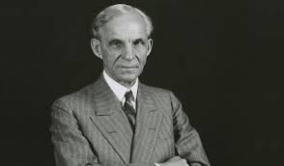
Entrepreneurs like Henry Ford profit by selling goods that the people desire at a price they are willing to pay.
Free Enterprise Requires a Free Market
Just about everyone can agree that people ought to be able to work in any occupation they choose; nobody thinks the government should be able to order some people to be janitors or ditch diggers, even if we are “running low” on people in these occupations. The right to determine one’s own destiny is ingrained in the American psyche.
The interesting fact is that this freedom of occupation is not only “the right thing to do,” it’s also the efficient thing to do! A person might just know that he will invent a better mousetrap, given enough time. In a free society, he has the right to follow his hunch for as long as he wants (so long as he pays for his materials fair and square). Similarly, a very successful corporate lawyer might decide to give up the stress and spend the rest of his days coaching Little League baseball. Economics doesn’t view this as a “waste,” because the workers’ desires must be taken into account—and no one can make that decision except the worker himself.
The benefits of free enterprise hold for all resources, not just labor. A basic motivation of those who believe that capitalism should be restricted is their perception that capitalism fails to allocate resources properly. They fail to understand that people disagree on how society’s resources ought to be deployed. It is not a simple matter of engineering, or of assembling “experts” with “noble hearts,” and banging out an objectively correct, five-year plan. Even people with the best intentions can have honest disagreements about the likely success of an R&D project, or whether travelers would prefer a bus route over a subway line.
In a free market, anyone is free to start a business and risk his own (or borrowed) capital, and let the consumers be the ultimate arbiters. This provides the best mechanism to harness the bits of knowledge and expertise that are dispersed throughout the economy. In contrast, under full-blown socialism an innovator would have to send his idea up the chain of command, and wait for approval before carrying it out. Beyond the bureaucracy, this system suffers from the fact that no group of planners—no matter how smart—can possibly amass all the information possessed by the whole of society. Consequently, the decisions of a socialist central board will always be more arbitrary and ignorant, even if the board is composed of the best and brightest (which, judging from history, seems highly unlikely).
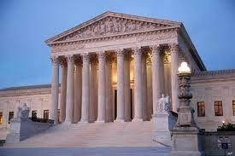
Courts must fairly enforce the law and contracts for the marketplace to operate efficiently.
Rule of Laws, not Men
One of the cornerstones of Western society is the idea that the same set of laws should apply to everyone. Citizens must know what the rules are beforehand, and not live in constant fear of the arbitrary caprice of the king or sultan. This strikes most Americans as a simple matter of justice.
Yet as with the institution of private property, the rule of law performs a utilitarian function too: it reduces uncertainty and allows businesses and consumers to invest in the future. There isn’t much real estate development or major factories near active volcanoes, and the reason is obvious: people won’t build if there’s a good chance the fruits of their efforts will be destroyed at any moment. By the very same token, the Industrial Revolution only occurred in Europe after the Magna Carta and other political events carved out a niche of autonomy for the private sector. There’s little point in amassing a great fortune if the political rulers can seize it at any time.
Extending the point, commercial agreements can only flourish if the legal system is predictable and impartial. To return to the oil example, American Airlines would be very reluctant to buy contracts for thousands of barrels of oil in the forward market, if it thought that Exxon would renege on the agreement in the event that oil prices rose, and could just bribe a corrupt judge to throw out the contracts. Notice that even Exxon would be hurt (in the long run) by such favoritism—once other businesses saw its special treatment by the government, they wouldn’t enter into long- range contracts with Exxon. Thus a dishonest judicial system can wipe out many of the benefits described in the above sections. (For a different example, Exxon won’t invest as much in new oil fields if it thinks it might get hit with an “excess profits” tax!)
Hong Kong’s place as the most economically free country in the world means that it is also one of the wealthiest.
The rule of law depends critically, too, on individuals’ acceptance and respect for the law. Investment is no more likely to occur in an area where some people regularly riot, destroy property, and steal, than it is to occur next to a volcano or under the rule of a despot.
Empirical Evidence—Indices of Economic Freedom
Although it’s a pleasant theory that economic freedom goes hand in hand with prosperity, the obvious question arises: is it actually true? The answer is a resounding “yes”! The Heritage Foundation and The Wall Street Journal, based on significant academic research by economists, put out an annual ranking of countries according to an “Index of Economic Freedom.” This index gives countries an overall percentage of economic freedom, based on 10 factors such as trade barriers, tax rates, monetary stability, ability to hire and fire workers, etc.
The richest countries are all on the upper end of the freedom scale; in 2021 the top five are Singapore, New Zealand, Australia, Switzerland, and Ireland. In contrast, those countries at the bottom end of the freedom scale are the poorest; in 2021 the bottom five are North Korea (dead last at 178), Venezuela, Cuba, Sudan, and Zimbabwe. The important point is that the ranking does not directly incorporate wealth or other indicators of prosperity. On the contrary, those desirable consequences are simply associated with the economic policies chosen by the countries in question.
Do Free Markets Always Work? Now Let’s Be Honest
We’ll address one final concern in this paper, namely the objection that capitalism requires a certain type of culture to work. In particular, some critics would say that free markets only work if there is a widespread degree of honesty among the population. Otherwise, who can say whether all of the alleged benefits described in the previous sections would actually come to fruition?
There are two responses to this. First, of course a social system—free or unfree—works better when the people in it are honest, kind, hard-working, etc. Yes, a capitalist society is more productive with honest people than with thieves, but the same is true for a feudal or communist society.
However, there is a deeper response. The level of trust, goodwill, honesty, and so forth in a society is not simply a God-given fact, like the amount of rainfall. On the contrary, social institutions themselves both affect and are affected by these traits. In particular, it is precisely the “commercial,” free market society that encourages people to honor their contracts, not defraud their customers, and so on. This is because in a free market, every transaction is voluntary. Therefore everyone—whether the low- skilled worker or billionaire entrepreneur—has an incentive to be honest in order to get people to trade with them, and to maintain his or her reputation so they can continue to engage in these voluntary transactions.
In contrast, one’s reputation is much less important in a politicized market. Here, all that matters is staying on the good side of the people in power. To see the difference, consider the following stark contrast. When Don Imus used language that offended many minorities and women, there was a huge outcry and he was fired from his major carriers. On the other hand, oppression in the Soviet Union went on for decades with little public expression of concern.
In the 1970s, Viktor Belenko flew his top- secret MIG fighter out of the Soviet Union to Japan and defected to the United States. Taken to visit a modern supermarket, he was sure he was being shown an artificial show and asked to be taken where people really shop. When told that it was real, that there were stores like it all over the country, he marveled and wondered why people were not running in and grabbing all they could. He could only conclude that there is something right about this place.
The conclusion is clear. Whatever the natural resources, culture, education, and other attributes a society has, its economy will be more productive—and better—with a free market.

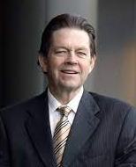
About the Author
Arthur B. Laffer is the founder and chairman of Laffer Associates, an economic research and consulting firm that provides global investment-research services to institutional asset managers, pension funds, financial institutions, and corporations. Since its inception in 1979, the firm’s research has focused on the interconnecting macroeconomic, political, and demographic changes affecting global financial markets.
Dr. Laffer has been widely acknowledged for his economic achievements. His economic acumen and influence in triggering a world-wide tax-cutting movement in the 1980s have earned him the distinction as the “Father of Supply-Side Economics.” He was also noted in TIME’s 1999 cover story on the “Century’s Greatest Minds” for inventing the Laffer Curve, which it deemed one of “a few of the advances that powered this extraordinary century.” His creation of the Laffer Curve was deemed a “memorable event” in financial history by the Institutional Investor in its July 1992 Silver Anniversary issue, “The Heroes, Villains, Triumphs, Failures and Other Memorable Events.”

